University of Regina

CS 455 – Mobile Computing
Milestone 3: Project Update

Michael Dickenson
Joel Rich
Santiago Félix Cárdenas

Dr. Orland Hoeber
Match 16th, 2017
Table of Contents

Motivation
Purpose
Key Features and Methodologies
Special Steps for Compiling
Final Notes

Motivation
We live in a time where we have become aware of the impact of our carbon footprint and pollution habits, and this awareness has led to a boom of green technologies, resources and new habits. However we still find ourselves making use of dirty and older technologies on a daily basis because we have no other alternative or it is too expensive to change over to a green method. We can't fix that people are using older tech but with our app who can hopefully help them keep track of what is happening with their car. Most modern vehicles have different types of diagnosis and analytics already built in, but older cars do not share the same luxuries or capabilities. However, an app like ONtheRoad would allow any person with a mobile device (iOS) to keep track of their everyday driving and provide them with different kinds of analytics, which could be important and helpful for them. Most modern vehicles provide us with some fuel efficiency information or distance traveled in a trip (or overall lifetime of the vehicle), yet the information is only available in the vehicles dashboard and it is overwritten as soon as we start a new trip, therefore, if we wanted to keep track of daily distance, daily fuel consumption and time spent driving, we would have to do it manually. We want to create a friendly application where the user can feel comfortable navigating, a powerful application that provides useful and meaningful information that the user can interpret and understand, and we want to create a universal application that can be practical to any user with an iOS device.

Purpose

The purpose of ON the Road is to provide the user with clear and simple analytics that can help improve the driving practices and experience of the user. Additionally, we wanted to develop something innovative and different from the countless applications that already exist that would also be able to potentially make a bigger impact than a simple game. After looking in the AppStore for similar applications, we were not able to find an application that could compare to our idea, therefore, we hope to bring something new for users interested in that area.

Key Features and Methodologies
Features and functionality
- Driving analytics
  - Driving time
    - Total driving time
    - Time spent driving at different speeds
  - Fuel efficiency
    - Over time
    - Over distance
  - Kilometers driven per trip
  - Map with overlay of fuel efficiency
- 3D touch features
  - Enable 3D touch to access shortcuts from device home screen
  - Add peek and pop feature to preview a map of a logged trip
- Allow users to create multiple vehicle profiles with the option of switching between a personal and a work vehicle
- Allow the user to discard trips
- Allow the app to run in the background
- Connect to the appropriate car information API to determine each vehicles fuel consumption and maximum acceleration

Start/Stop Trip:
The initial screen of the application has been redesigned with the purpose of displaying to the user different information about the trip. Our home screen was designed to be a navigation screen in addition to the main navigation bar at the bottom of the screen. However, following the feedback given to us in the project proposal, we decided to take advantage of the device capabilities and do something more functional for the user, instead of creating a different interaction mechanism that would duplicate an existing one.
Adding on, we have also added a page control at the bottom of the screen so the user can have a better idea of what the application and the interface provide.
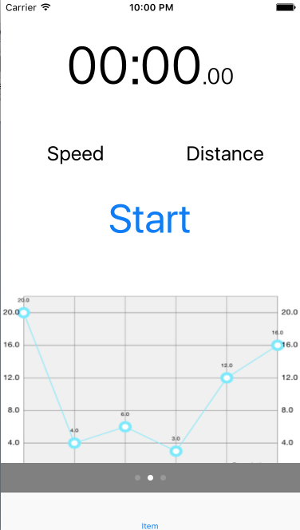
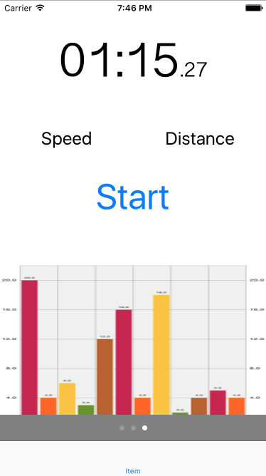

Create/Edit a vehicle profile:
To create a vehicle profile, the users have to select from a list the vehicle make, model, year and trim. Each field must have a selected item before the user can select an item in the next field. By allowing the user to select from a list instead of making them type the information, and by disabling user interaction with the text fields (while the previous text fields are not completed), we eliminate any accidental error created by the user that could cause the application to crash. Moreover, by making API requests and giving the user valid information we are able to acquire and display the more detailed information about the vehicle that most users would not know without looking at their vehicle guidebook (efficiency, torque, horsepower, etc). Finally, the user has the option to select their vehicle type, whether it is for personal use or for work.

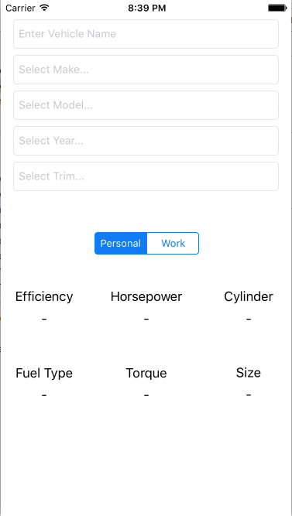
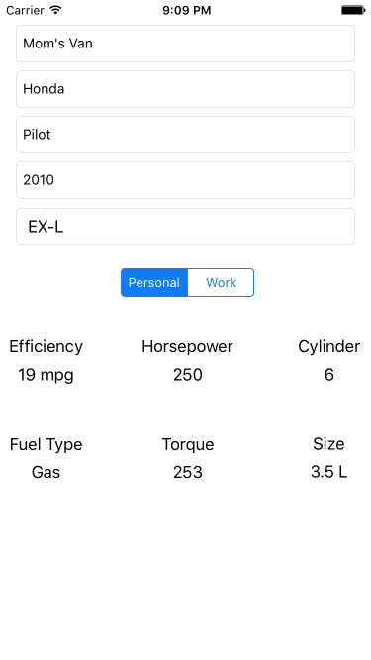

View/Edit/Delete a log entry:
After ending a trip it will be added to the users log of all their trips. The user will be able to to open each trip entry to see the general information about the trip as well as see a map that overlays a coloured line representing their driving efficiency through out the trip.

GPS:
For the GPS we are taking our readings every second, the original plan was to take readings every 1/5 of a second however taking our readings this often was causing issues with other areas of the project. When we take our GPS readings we save the timestamp, latitude, longitude, distance since the last reading and the time since the last reading, everything else we discard

Analytics:
For the current model for the analytics we are using roughing numbers to allow us to get the general idea of the trip and its efficiency but there is a degree of known inaccuracy in a lot of our metrics. If this app was to be released we would need to spend more time studying how to perform these analytics and get more accurate results for our efficiency models.
As stands we are currently gathering the following information and performing the following calculations
- startTime
  - Gained by grabbing the devices current time when the user hits “Start”.
- endTime
  - Gained by grabbing the devices current time when the user hits “Stop”.
- tripLength
  - To find the total duration of the trip we tally all the timestamps taken during the trip.
- tripDistance
  - to find the total distance of the trip we tally each points distance from the last point taken.
- VehicleActual
  - This is the recorded fuel consumption for the vehicle being used for the current trip, this value is read from the vehicle API. We use this number in some of our calculations and for the live and analytic charts
- vehicleMaxAccel
  - This is the calculated maximum acceleration of the vehicle being used for the current trip, we get this value from the vehicles 0-60 time read out of the vehicle API. We use this value for figuring out how hard the user is using their vehicle and generating our efficiency values from that.
- tripLocationData
  - tripLocationData is the array we use to store the information we want for each GPS point
    - timeStamp
      - This is the timestamp of the GPS point
    - latitude & longitude
      - These two variables give us the coordinates of the GPS point
    - distance
      - This is the distance from the previous tripLocationData item
    - instSpeed
      - This is the speed that the user was traveling at the time the GPS point was saved
    - instAccel
      - This is the current acceleration of the user at the time the GPS point is saved. This is gained from taking the instSpeed of the current tripLocationData and subtracting it from the previous instSpeed and dividing the result by the time since the last measure. In physics this is stated as (delta V)/(delta T).
    - efficiencyRatio
      - efficiencyRatio is our variable we use to figure out how harshly the user is driving and allows us to create our rough calculation for finding out the users current L/100km. To find the efficiencyRation at a given point we take the abs instAccel reading and divide it by vehicleMaxAccel and then adding one. abs(instAccel/vehicleMaxAccel)+1

Acceleration Efficiency:
Using the efficiencyRatio readings we’ll decide how efficiently they are accelerating
1/4 vehicleMaxAccel | Good
1/2 vehicleMaxAccel | Average
3/4 vehicleMaxAccel | Poor
Anything past 3/4 | Bad

Fuel Consumption:
The fuel consumption is never a value that we store, we derive it everytime we go to display the relevant charts as we figured it was easier on the processor to have to do a small calculation from time to time than to do our permanent storage methods.
The calculation looks like: vehicleActual x efficiencyRatio, and it gets applied in several different areas in slightly different way.

Graphs
For the visuals displayed in the analytics screen we are going to have three graphics.
The first graphic will be a circle graph broken into all the different efficiency range groupings to show the user how much of their trip they spent driving in each category. Unfortunately the library we are using for our charts is forcing value labels on the sections of the chart so we are unable to display the chart as we would like.
The second graphic will be a bar graph that shows the user’s fuel consumption in L/100km over time. To get this we take the trips total time, divide it into 10 segments and find the average fuel consumption for each segment of the bar graph. This allows the user to see how well they were driving throughout the duration of their trip.

The third graphic will be a line graph that shows the user’s fuel consumption in L/100km over distance. To get this we take the trips total distance, divide it into 10 segments and find the average fuel consumption for each segment of the graph. This allows the user to see how well they were driving throughout the total distance of their time, this chart might become skewed if the user has a long period of time spent in a city followed by a long distance drive on a highway.

